You are given a **0-indexed** 2D matrix grid of size n x n, where (r, c) represents:

* A cell containing a thief if grid[r][c] = 1
* An empty cell if grid[r][c] = 0

You are initially positioned at cell (0, 0). In one move, you can move to any adjacent cell in the grid, including cells containing thieves.

The **safeness factor** of a path on the grid is defined as the **minimum** manhattan distance from any cell in the path to any thief in the grid.

Return *the* ***maximum safeness factor*** *of all paths leading to cell* (n - 1, n - 1)*.*

An **adjacent** cell of cell (r, c), is one of the cells (r, c + 1), (r, c - 1), (r + 1, c) and (r - 1, c) if it exists.

The **Manhattan distance** between two cells (a, b) and (x, y) is equal to |a - x| + |b - y|, where |val| denotes the absolute value of val.

**Example 1:**

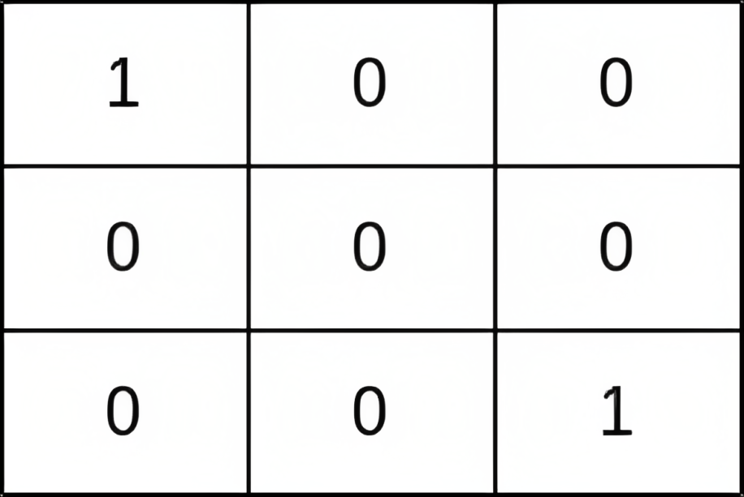

Input: grid = [[1,0,0],[0,0,0],[0,0,1]]  
Output: 0  
Explanation: All paths from (0, 0) to (n - 1, n - 1) go through the thieves in cells (0, 0) and (n - 1, n - 1).

**Example 2:**

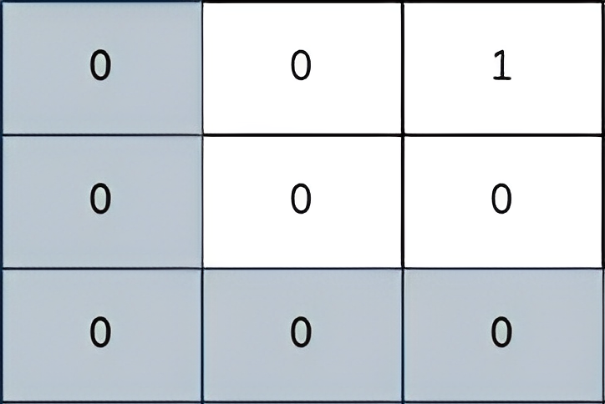

Input: grid = [[0,0,1],[0,0,0],[0,0,0]]  
Output: 2  
Explanation: The path depicted in the picture above has a safeness factor of 2 since:  
- The closest cell of the path to the thief at cell (0, 2) is cell (0, 0). The distance between them is | 0 - 0 | + | 0 - 2 | = 2.  
It can be shown that there are no other paths with a higher safeness factor.

**Example 3:**

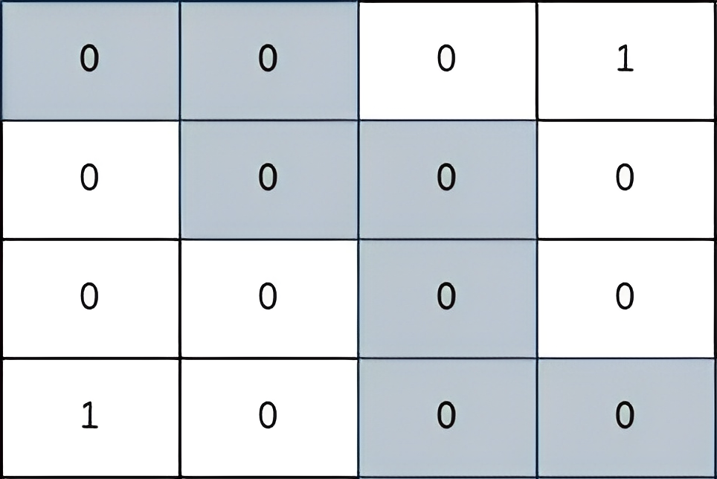

Input: grid = [[0,0,0,1],[0,0,0,0],[0,0,0,0],[1,0,0,0]]  
Output: 2  
Explanation: The path depicted in the picture above has a safeness factor of 2 since:  
- The closest cell of the path to the thief at cell (0, 3) is cell (1, 2). The distance between them is | 0 - 1 | + | 3 - 2 | = 2.  
- The closest cell of the path to the thief at cell (3, 0) is cell (3, 2). The distance between them is | 3 - 3 | + | 0 - 2 | = 2.  
It can be shown that there are no other paths with a higher safeness factor.

**Constraints:**

* 1 <= grid.length == n <= 400
* grid[i].length == n
* grid[i][j] is either 0 or 1.
* There is at least one thief in the grid.